Progress Report for Unit 6 and Goal Setting for Unit 7: Physics 2024

Please fill in the 2nd and 5th columns of this table.
Standard | What you Earned | Assessment evaluated | Target Levels for Unit 6 | Are your scores Below (1 or 2), Meet, or Above Target? | Pattern of Performance  (to be done during conferencing) | Target Levels for Unit 7
Experimental Design |  | Lab 6D: Energy of a Cart on an Incline | Proficient |  |  | Proficient
Data Analysis |  |  | Proficient |  |  | Proficient
Arguing a Scientific Claim |  |  | Advanced |  |  | Advanced
Using Feedback |  |  | Proficient |  |  | Proficient
Creating Explanations |  | Unit 6 Test | Advanced |  |  | Advanced
Problem Solving |  |  | Advanced |  |  | Advanced
Interpreting Graphs |  |  | Proficient |  |  | Proficient
Creating Graphs |  |  | Proficient |  |  | Proficient
Engaging with Content |  | Content Mastery Checkpoint in combination with Project requirements | Proficient |  |  | Proficient
Engineering Design Process |  | Unit 6 Project: Wind Turbine | Proficient |  |  | Proficient
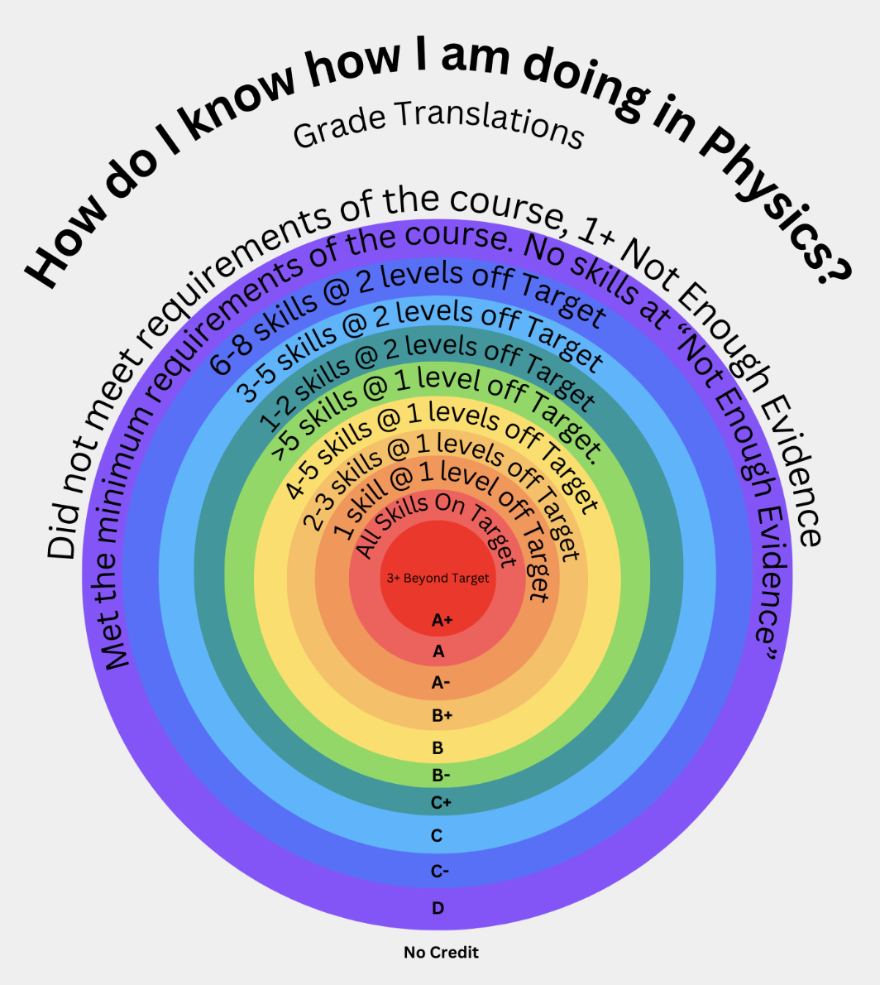
Your score summary:
- # of practices at the Target Level: ____
- # of practices above the Target Level: ____
- # of practices 1 below the Target Level: ____
- # of practices 2 below the Target Level: ____
- # of practices at “Not Enough Evidence”: ____

Translate current achievement levels into a traditional grade, using graphic: ________

Are you currently achieving your goal? Yes or No. Do you need any help from me? Yes or No.

PLEASE GO TO THE GOOGLE CALENDAR LINK NOW TO SCHEDULE YOUR SPRING CONFERENCE. The deadline for this is _____.

For this class, the end-of-the-year targets are 7 Proficient and 3 Advanced to earn an A. Using the Pattern of Performance, my current scores translate to a grade of _______. This will be my minimum grade for Physics as long as I complete the following items:

My Personal Action Plan & Next Steps:
- I have submitted _______ out of 16 formal lab reports. I must submit _____ more labs to earn credit for this class.
- I complete the Unit 7 test to the best of my ability.
- I engage with full effort to build and document the Unit 7 project, submitting it by the due date.
- My work is my own, and no narrative part of any assignment is the same as anyone else’s.
- I complete the reflection assignment to provide evidence of maintaining or improving performance by ________.
- If I need to renegotiate this contract or get support to meet these requirements, I will schedule a follow-up meeting(s) using the calendar link on the task list. The last possible date for EOY Conferencing is ________.
- Specific assigned work (listed below) will help me improve in areas that I find challenging. I will complete these items, showing an authentic effort to maintain or improve performance

_______________________________________________________________________________________________________________

_______________________________________________________________________________________________________________

_______________________________________________________________________________________________________________

_______________________________________________________________________________________________________________

_______________________________________________________________________________________________________________

In return for completing the above items, I will earn at least a grade of _____ no matter how I do on the last set of assessments. If I show improvement, my grade may increase as per the grade translation chart. If I do not complete the items above, this contract is void, and I earn whatever grade the last set of assessments translates into.

My signature below communicates that I understand this contract. If there is ever any question or concern, I can make an appointment to ask questions and get support and clarification.

___________________________________ ___________________________________
Student Signature Instructor Signature

